**PRACTICAL 2**

**Database Management Systems**

|  |  |
| --- | --- |
| **NAME: VARUN KHADAYATE** | **ROLL NO: A016** |
| **PROGRAM: BTECH SY** | **DIVISION: CSBS** |
| **BATCH: 1** | **DATE OF EXPERIMENT: 01/02/2020** |

# AIM

To Understand and Implement Data Defining Language (DDL) Statements.

# THEORY

## 1] CREATE TABLE

The CREATE TABLE statement is used to create a table in SQL. A table comprises of rows and columns. So while creating tables we need to provide all the information to SQL about the names of the columns, type of data to be stored in columns, size of the data, constraints if any, etc.

### i] Syntax:

create table <table_name>

( <column_name> <data_type> (<size>) [primary key] [not null],

<column_name> <data_type> (<size>) [primary key] [not null],

<column_name> <data_type> (<size>) [primary key] [not null],

.

.

<column_name> <data_type> (<size>) [primary key] [not null],

[primary key (<column_name>[,<column_name>,<column_name>..,<column_name>])]

);

### ii] Description:

table_name                         : name of the table.

column1                               : name of the first column.

data_type                            : Type of data we want to store in the particular column.

For example number for numeric data.

size                                         : Size of the data we can store in a particular column.

For example if for a column we specify the data_type as number and size as 10 then this column can store number of maximum 10 digits.

### iii] Example

If you want to create a table called Employee which has all the attributes like Empid, Ename, Address, Salary.

Then, issue the following command in the editor

Create table Employee (Empid varchar(6) , Ename varchar(15) , Address varchar(25) , Salary number(5));

## 2] ALTER TABLE

The SQL ALTER TABLE command is used to add, delete or modify columns in an existing table. You can also use the ALTER TABLE command to add and drop various constraints on an existing table.

### i] Syntax:

a] Add a New Column

The basic syntax of an ALTER TABLE command to add a New Column in an existing table is as follows.

alter table <table_name>  
add ( <new_column_name> <new_data_type> (<new_size>) ,  
<new_column_name> <new_data_type> (<new_size>) ,

.

.

<new_column_name> <new_data_type> (<new_size>) );

### b] Modify column

It is used to modify the existing columns definition in a table. Multiple columns definitions can also be modified at once.The basic syntax of an ALTER TABLE command to change the DATA TYPE and SIZE of a column in a table is as follows:

alter table <table_name>  
<modify> <column_name> <new_data_type> (<new_size>),  
<column_name> <new_data_type> (<new_size>),  
.  
.  
<column_name> <new_data_type> (<new_size>);

#### ADD PRIMARY KEY

The basic syntax of an ALTER TABLE command to ADD PRIMARY KEY constraint to a table is as follows.

alter table <table_name>  
add primary key  
(<column_name>,<column_name>,<column_name>..,<column_name>);

#### DROP PRIMARY KEY

alter table <table_name>  
drop primary key;

### c] Drop column

DROP COLUMN is used to drop column in a table. The user can use this command to delete the unwanted columns from the table.The basic syntax of an ALTER TABLE command to DROP COLUMN in an existing table is as follows.

alter table <table_name>  
drop column  
< column_name > [,<column_name>,<column_name>..,<column_name >];

## 3] DROP TABLE

The SQL DROP TABLE statement is used to remove a table definition and all the data and constraints for that table. Once a table is deleted then all the information available in that table will also be lost forever.

### i] Syntax:

drop table <table_name >;

## Overview of Data Types

A data type is a classification of a particular type of information or data. Each value manipulated by database has a data type.

The data type of value associates a fixed set of properties with the value.

These properties allow the database to treat values of one data type differently from values of another.

Data Types Supported by the Database

Character_ data types  
{  
VARCHAR (size [ BYTE | CHAR ])  
}  
Number_ data types  
{  
NUMBER [ (precision [, scale ]) ]  
}  
Date_datatypes  
{  
DATE(_)  
}

### Data Types

|  |  |
| --- | --- |
| Data Type | Description |
| VARCHAR(size [BYTE | CHAR]) | Variable-length character string having maximum length size bytes or characters.  You must specify size for VARCHAR.  BYTE indicates that the column will have byte length semantics.  CHAR indicates that the column will have character semantics. |
| NUMBER | Number is used for store the numerical values in database |
| DATE | This data type contains the date time fields YEAR, MONTH, DAY, HOUR, MINUTE and SECOND. It does not have fractional seconds or a time zone |

# CODE SNAPS

## CREATE TABLE

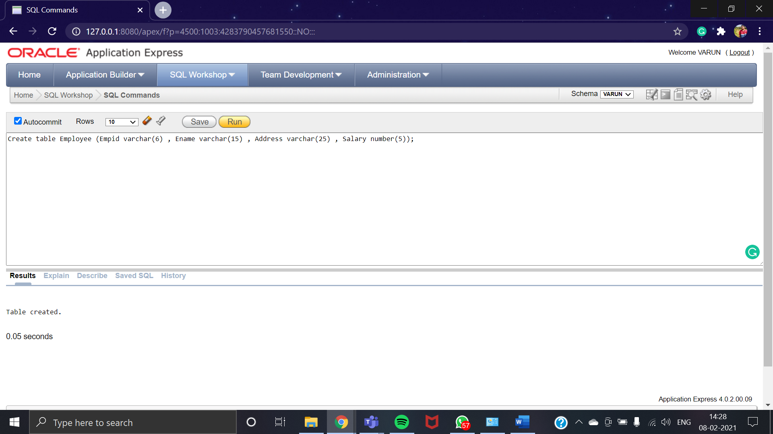

## ALTER TABLE

### Add a New Column

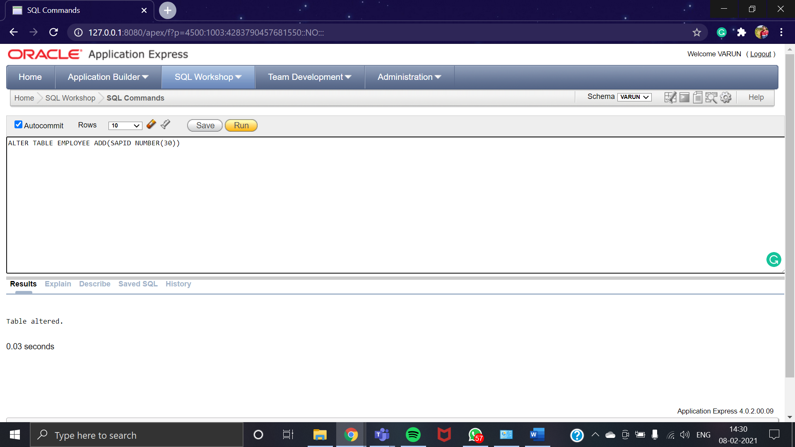

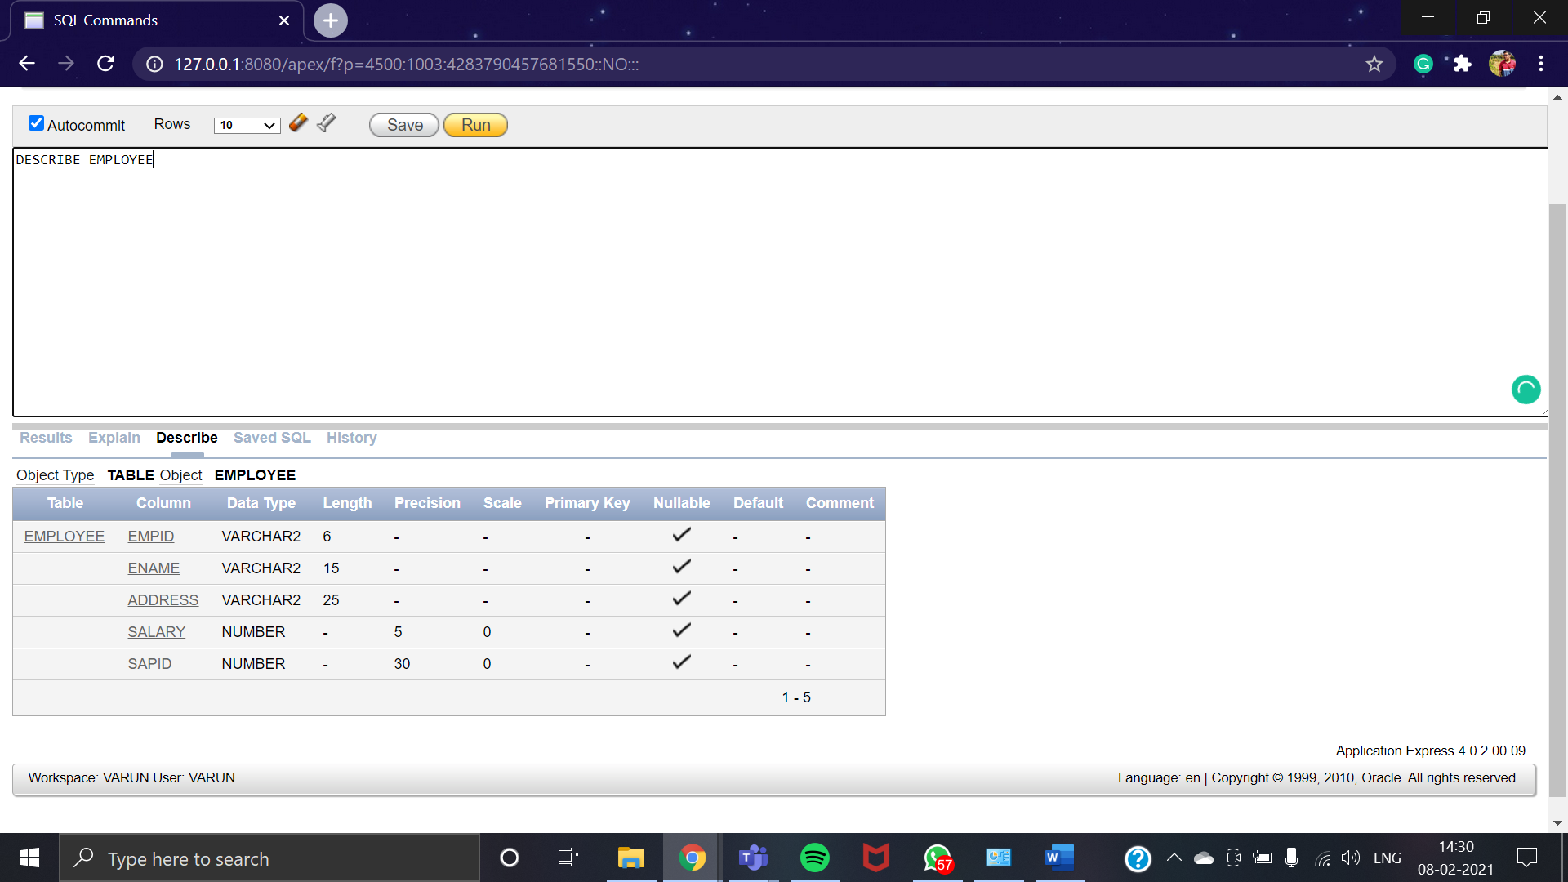

### Modify column

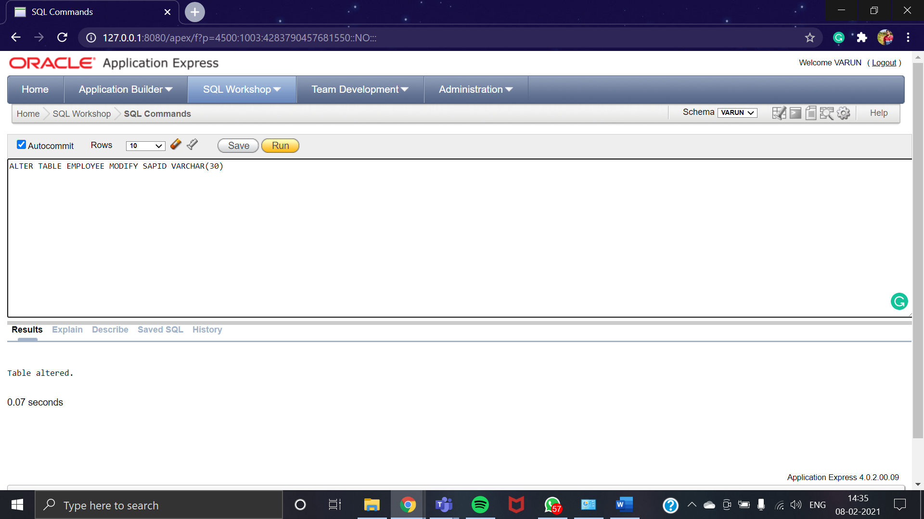

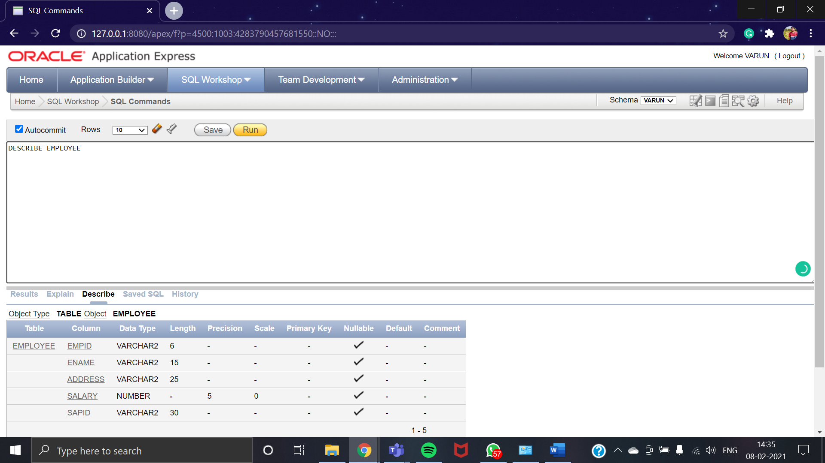

#### ADD PRIMARY KEY

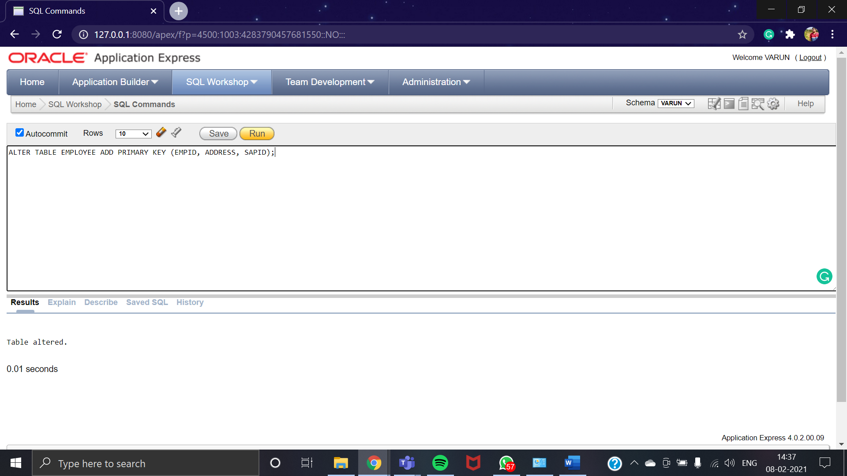

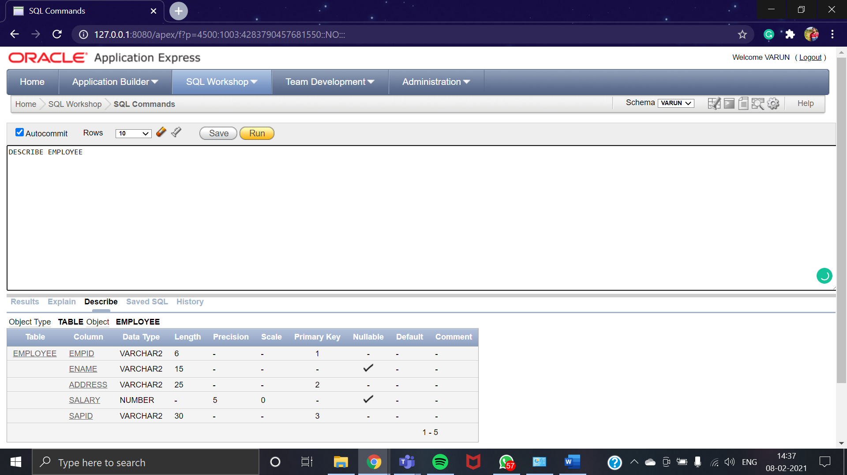

#### DROP PRIMARY KEY

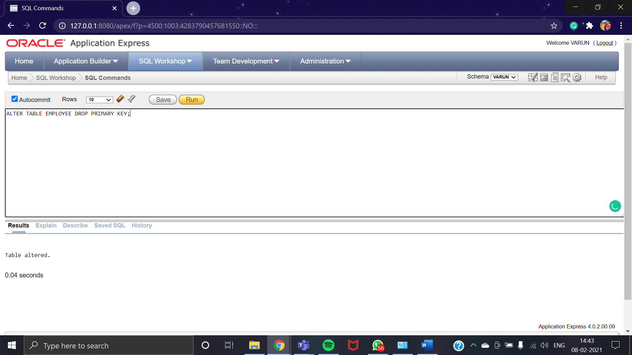

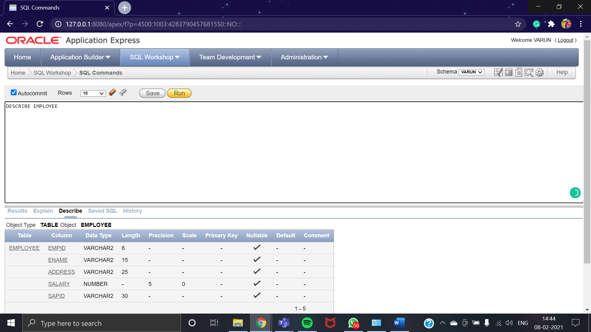

### Drop column

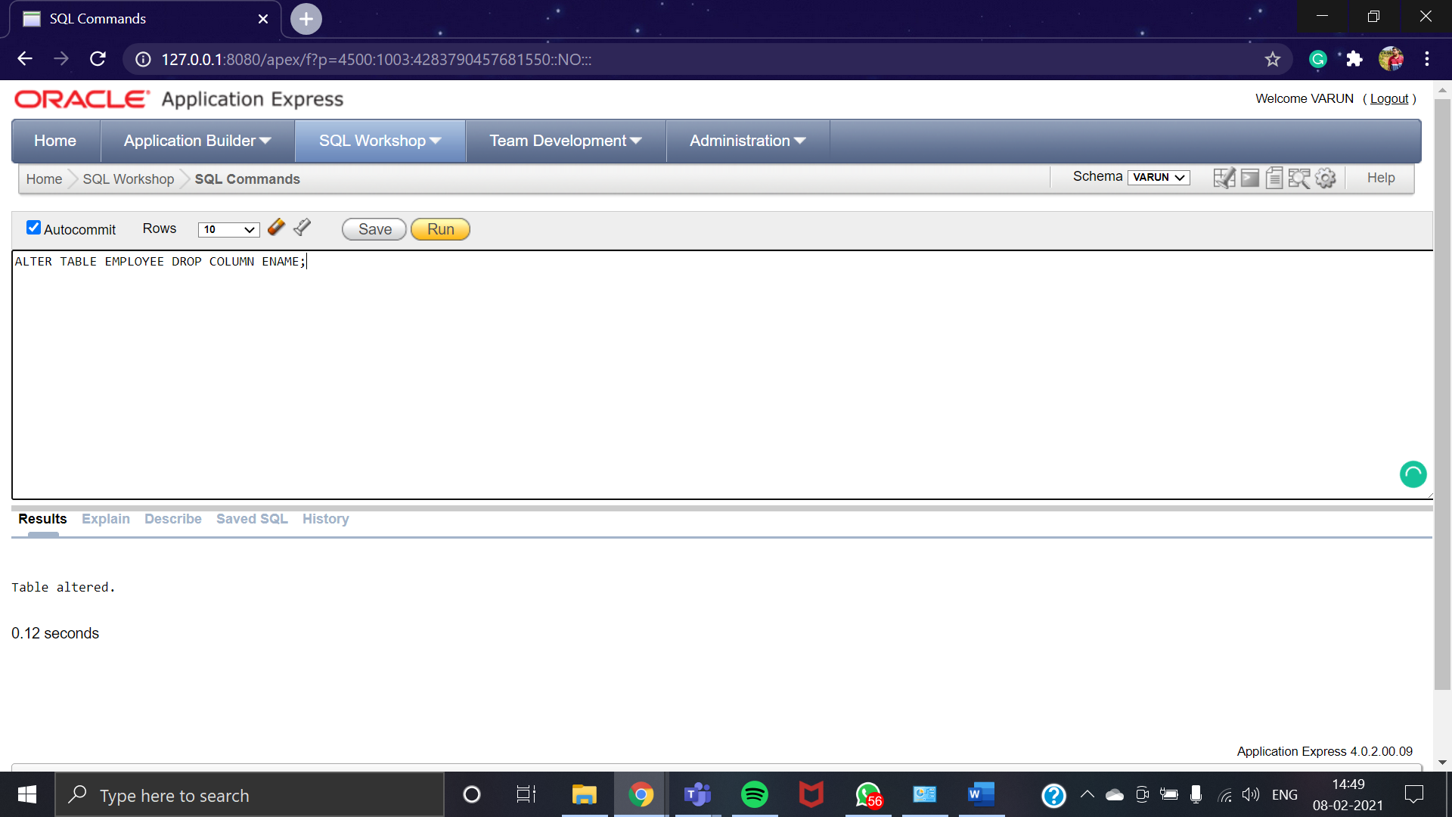

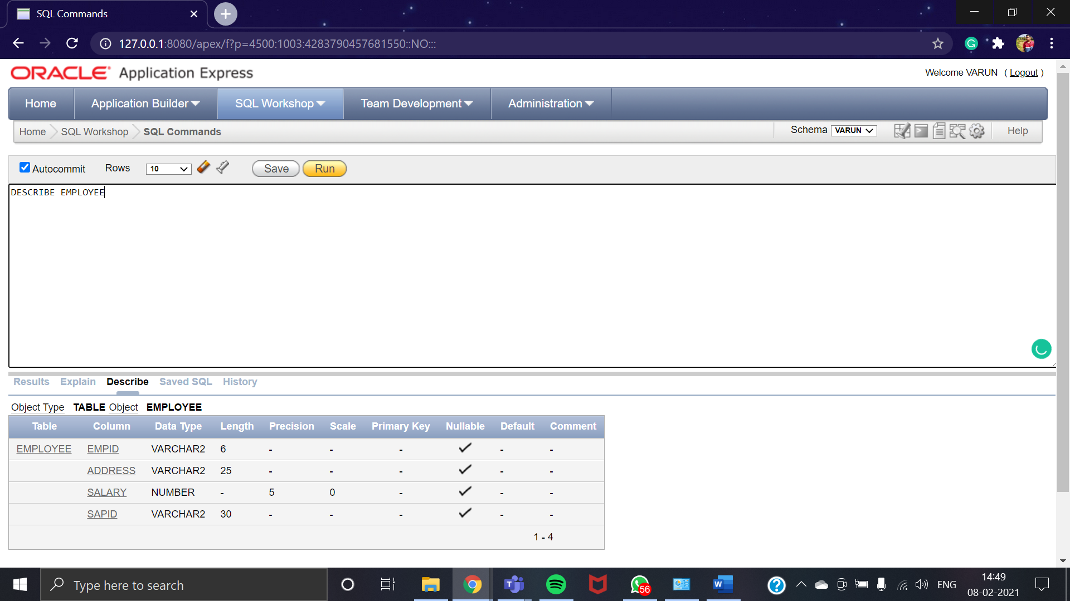

## DROP TABLE

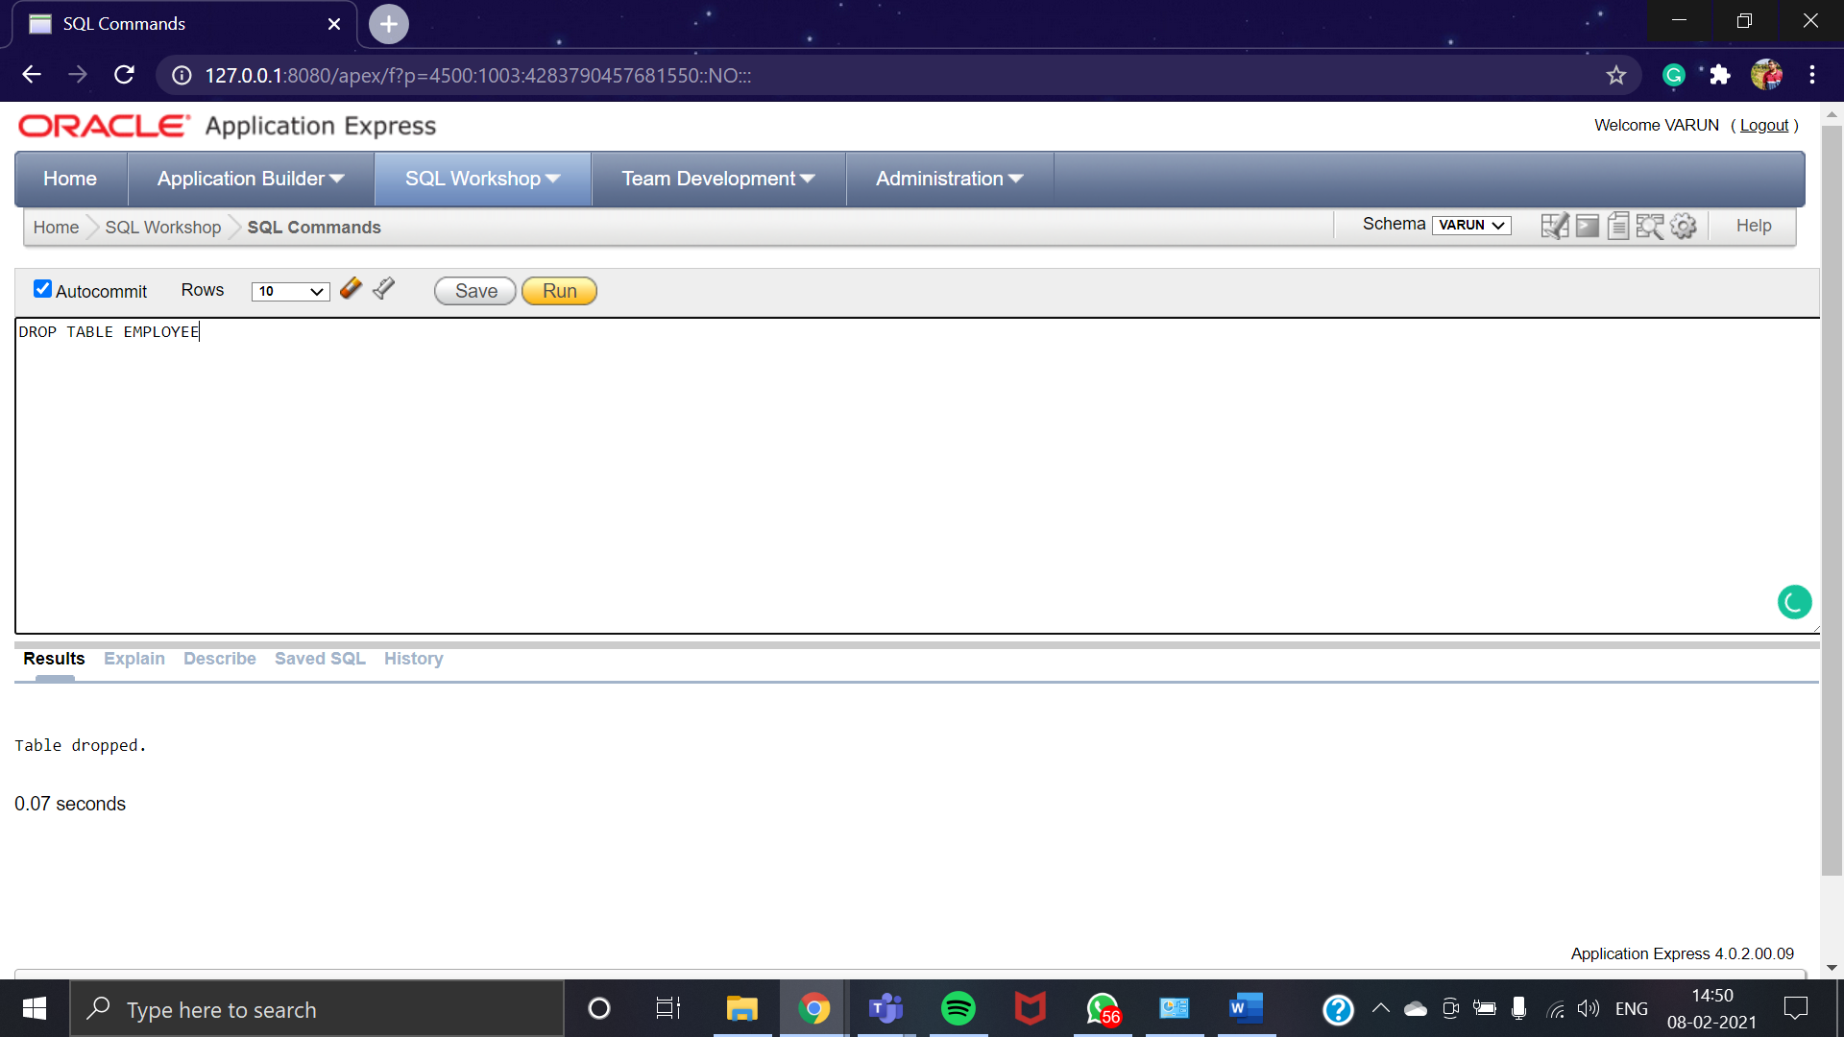

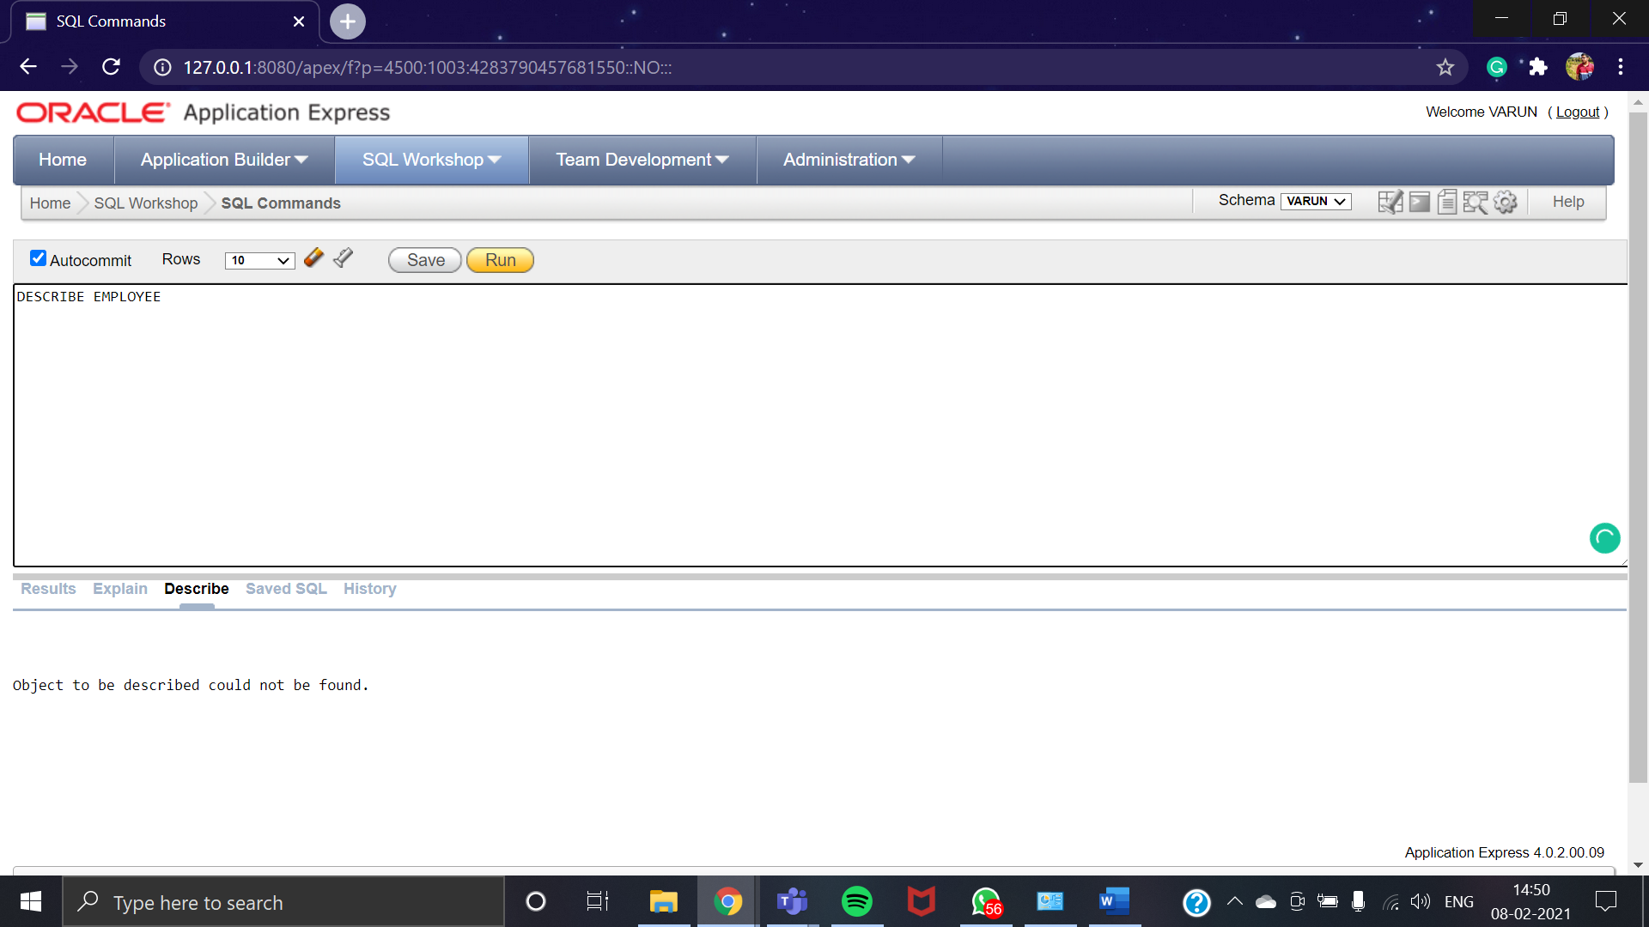

# CONCLUSION

At the end of this practical we were able to understand the various aspects of Data definition language commands like:

* Creating a table, with or without constraints.
* Understanding Data types.
* Altering the structure of the table like adding attributes at later stage, modifying size of attributes or adding constraints to attributes.
* Removing the table created, i.e Drop table in SQL.